CONCORDEX

Sequential list of all Tarot cards and Hexagrams referred to in
the first spread of the 2026 October mapping

-----------------------------------------------------------------------------------------------------------------------------------------------------------------------------------------------------------------------------------------------------------------------------------------------------------------------------

10 = 10 = 10 = 30
------------------------------------------------------------------------------------------------------------------------------------------------------------------------------------------------------------------------------------------------------------------------------------------------

~ TREADING ~ BEING = THE RECOGNITION OF FEELINGS ~ THE WHEEL OF FORTUNE X
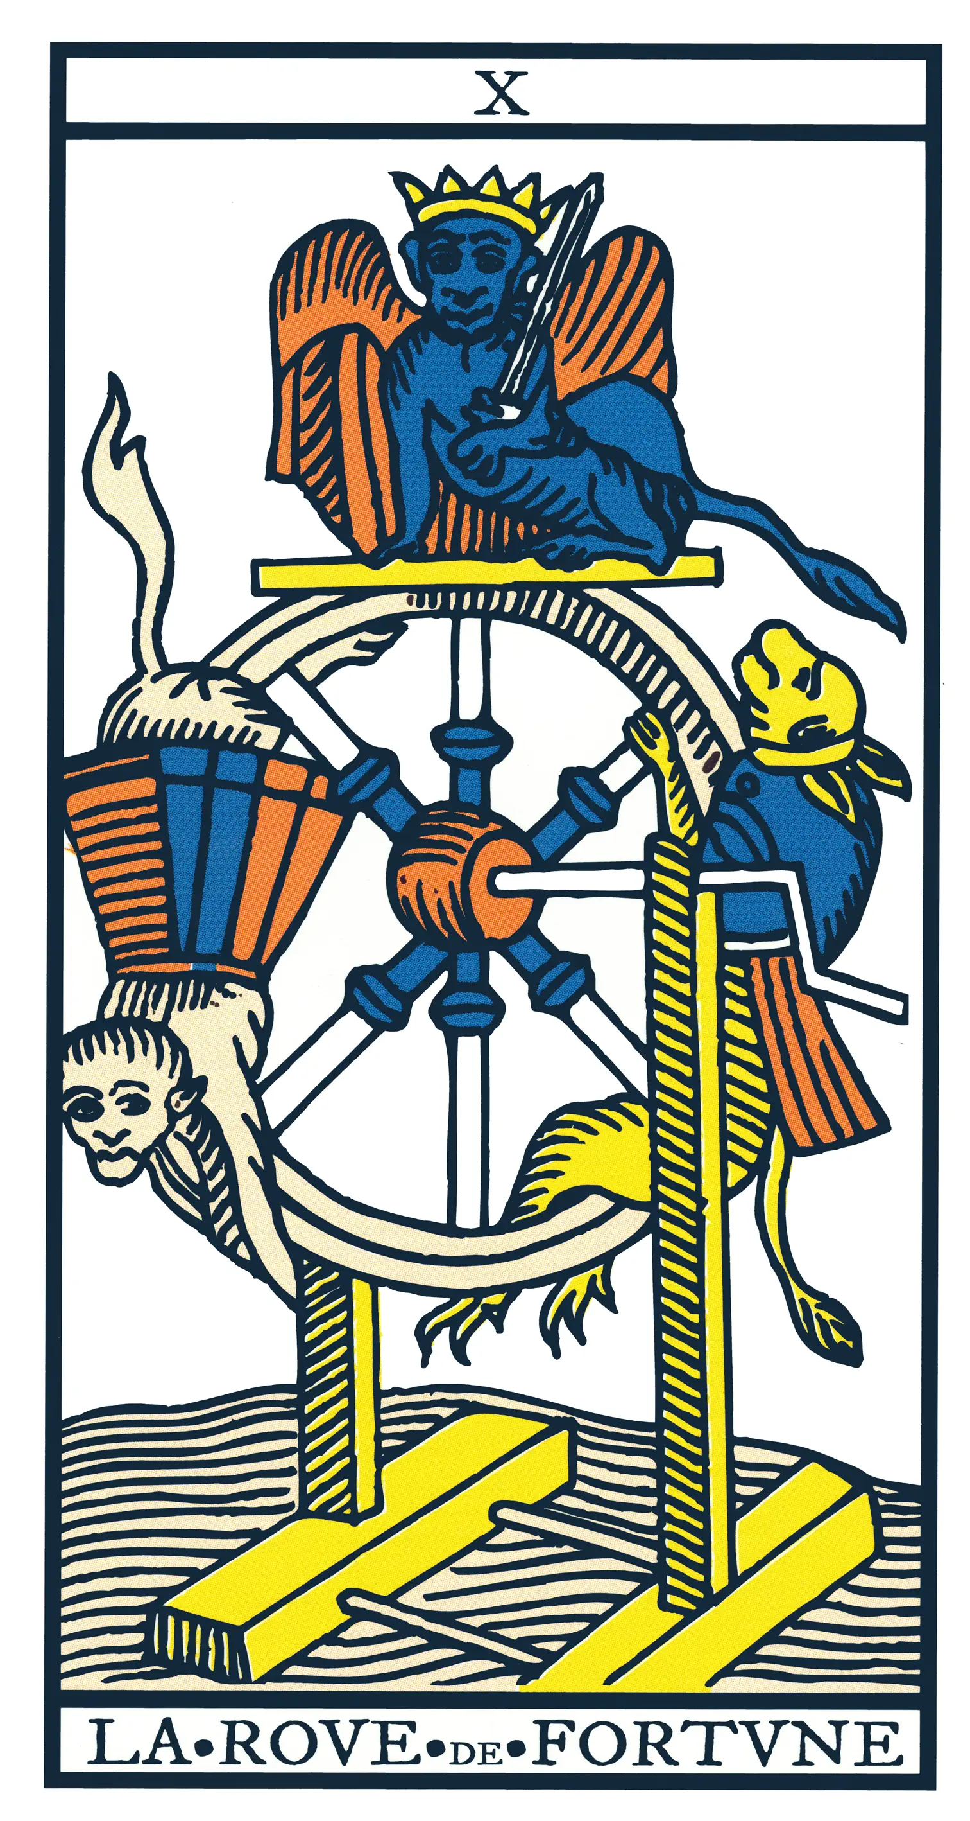

I Ching hexagram: 30 ~ Clinging Fire
Human Design: gate 30 ~ Insight
Gene Key: 30 ~ Shadow ~ Desire
Gift ~ Lightness, Siddhi ~ Rapture

---------------------------------------------------------------------------------------------------------------------------------------------------------------------------------------------------------------------------------------------------

-----------------------------------------------------------------------------------------------------------------------------------------------------------------------------------------------------------------------------------------------------------------------------------------------------------------------------
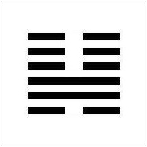

I Ching hexagram: 46 ~ Pushing Upward
Human Design: gate 46 ~ Determination
Gene Key: 30 ~ Shadow ~ Seriousness
Gift ~ Delight, Siddhi ~ Ecstasy

----------------------------------------------------------------------------------------------------------------------------------------------------------------------------------------------------------------------------------------------------------------------------------------------------------------------------

----------------------------------------------------------------------------------------------------------------------------------------------------------------------------------------------------------------------------------------------------------------------------------------------------------------------------

Conscious aim for Breakthrough, HD gate 43
represented by Major Arcanum VI, The Lover
in harmonic resonance with the Chariot

NUMEROLOGICAL SIGNIFICANCE WITHIN THE VERTICAL LINEUP
21 + 6 ~ 4 + 3 = 7 = 27

----------------------------------------------------------------------------------------------------------------------------------------------------------------------------------------------------------------------------------------------------------------------------------------------------------------------------

4 + 3 = 7 ~ 3 + 7 = 10 ~ 10 + 6 = 16

FREQUENTIAL RESONANCE
VI The Lover reflecting the charioteer VII seeking 43 Breakthrough
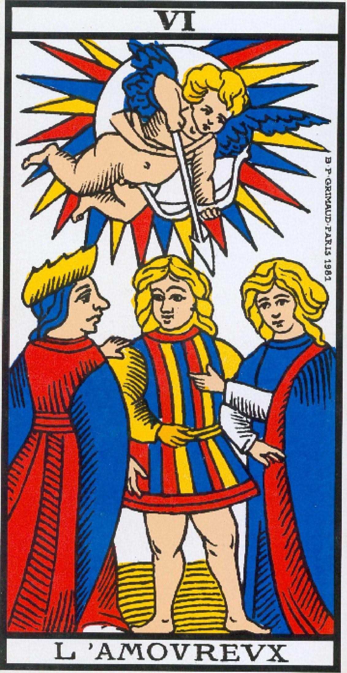


I Ching hexagram: 43 ~ Breakthrough
Human Design: gate 43 ~ Insight
Gene Key: 43 ~ Shadow ~ Deafness
Gift ~ Insight, Siddhi ~ Epiphany

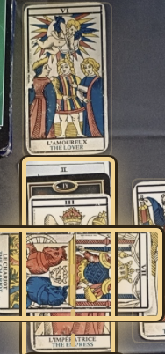
43
IV+III

The (Invisible) Emperor)
The Empress

------------------------------------------------------------------------------------------------------------------------------------------------------------------------------------------------------------------------------------------------------------------------------------------------

-----------------------------------------------------------------------------------------------------------------------------------------------------------------------------------------------------------------------------------------------------------------------------------------------------------------------------
16 + 6 = 22
FREQUENTIAL RESONANCE
The Tower XVI ~ The Lover VI

21 + 6 = 27.
FREQUENTIAL RESONANCE
The Empress ~ VII The Chariot Covering a hermit + 2 of Wands
Crowned by VI The Lover


I Ching hexagram: 16 ~ Enthusiasm
Human Design: gate 16 ~ Skills
Gene Key: 16 ~ Shadow ~ Indifference
Gift ~ Versatility, Siddhi ~ Mastery

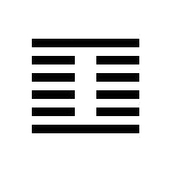
I Ching hexagram: 27 ~ Nourishment
Human Design: gate 27 ~ Caring
Gene Key: 43 ~ Shadow ~ Selfishness
Gift ~Altruism, Siddhi ~ Selflessness

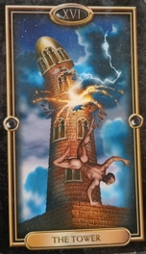
22
2 + 2
16 + 6 = 22
XXII Jupiter
II The Priestess
27

2+7 = 9

The Hermit

---------------------------------------------------------------------------------------------------------------------------------------------------------------------------------------------------------------------------------------------------------------------------------------------------------------------------

-----------------------------------------------------------------------------------------------------------------------------------------------------------------------------------------------------------------------------------------------------------------------------------------------------------------------------
Unconscious foundation of Values

NUMEROLOGICAL SIGNIFICANCE WITHIN THE VERTICAL LINEUP
27 + 23 = 50
----------------------------------------------------------------------------------------------------------------------------------------------------------------------------------------------------------------------------------------------------------------------------------------------------------------------------
FREQUENTIAL RESONANCE
XXIII Juno


I Ching hexagram: 50 ~ The Cauldron
Human Design: gate 50 ~ Values
Gene Key: 50 ~ Shadow ~ Corruption
Gift ~ Equilibrium, Siddhi ~ Harmony

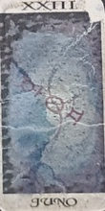
14

(2+7+2+3)
XIV Temperance

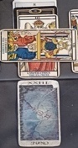

----------------------------------------------------------------------------------------------------------------------------------------------------------------------------------------------------------------------------------------------------------------------------------------------------------------------------

-----------------------------------------------------------------------------------------------------------------------------------------------------------------------------------------------------------------------------------------------------------------------------------------------------------------------------

NUMEROLOGICAL SIGNIFICANCE WITHIN THE VERTICAL LINEUP
9 + 9 = 18 ~ 11 + 9 = 20
-----------------------------------------------------------------------------------------------------------------------------------------------------------------------------------------------------------------------------------------------------------------------------------------------------------------------------
9 + 9 = 18

FREQUENTIAL RESONANCE
VIIII The Hermit ~ The Moon ~ Focus ~ Correction


I Ching hexagram: 18 ~ Work on what has been spoilt
Human Design: gate 18 ~ Correction
Gene Key: 18 ~ Shadow ~ Judgement
Gift ~ Integrity, Siddhi ~ Perfection

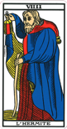
18

(9+9=18)
XVIII The Moon

-----------------------------------------------------------------------------------------------------------------------------------------------------------------------------------------------------------------------------------------------------------------------------------------------------------------------------

-----------------------------------------------------------------------------------------------------------------------------------------------------------------------------------------------------------------------------------------------------------------------------------------------------------------------------
9 + 9 = 18 ~ 11 + 9 = 20

NUMEROLOGICAL SIGNIFICANCE WITHIN THE ENTIRE CELTIC CROSS FORMAT

11 + 7 + 9 = 27 ~ 6 + 3 + 23 = 32 ~ 2 + 9 = 11
FREQUENTIAL RESONANCE
VIIII The Hermit ~ The Moon ~ Focus ~ Correction

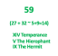

11 + 9 = 20

NUMEROLOGICAL SIGNIFICANCE WITHIN THE VERTICAL LINEUP
XI Strength ~ IX The Hermit ~ XX Judgement ~ Contemplation ~ The Now
11 + 9 = 20
FREQUENTIAL RESONANCE
VIIII The Hermit ~ The Moon ~ Focus ~ Correction


I Ching hexagram: 59 ~ Dispersion
Human Design: gate 59 ~ Sexuality
Gene Key: 59 ~ Shadow ~ Dishonesty
Gift ~ Intimacy, Siddhi ~ Transparency



I Ching hexagram: 20 ~ Contemplation
Human Design: gate 20 ~ The Now
Gene Key: 18 ~ Shadow ~ Superficiality
Gift ~ Self-Assurance, Siddhi ~ Presence

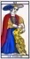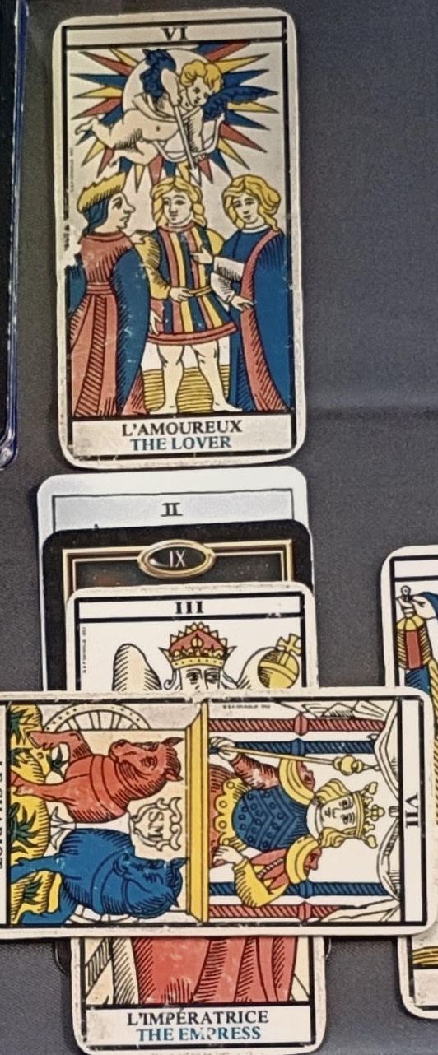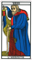
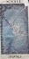
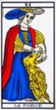
20

(11+9=20)
XX Judgement

-----------------------------------------------------------------------------------------------------------------------------------------------------------------------------------------------------------------------------------------------------------------------------------------------------------------------------

-----------------------------------------------------------------------------------------------------------------------------------------------------------------------------------------------------------------------------------------------------------------------------------------------------------------------------
27 + 32 + 11 = 70 = 7
70 – IX The Hermit’s solitary path points to the need for every
Seeker’s courage and Self-determination to be seen as the Fool
following his/her innocent Inner Child on the path of heart leading
into a new paradigm of Peace and Harmonic Resonance.

FREQUENTIAL RESONANCE

27 Caring ~ 32 Continuity ~ 11 Power of Peace


I Ching hexagram: 61 ~ Inner Truth
Human Design: gate 59 ~ Mystery
Gene Key: 61 ~ Shadow ~ Psychosis
Gift ~ Inspiration, Siddhi ~ Sanctity

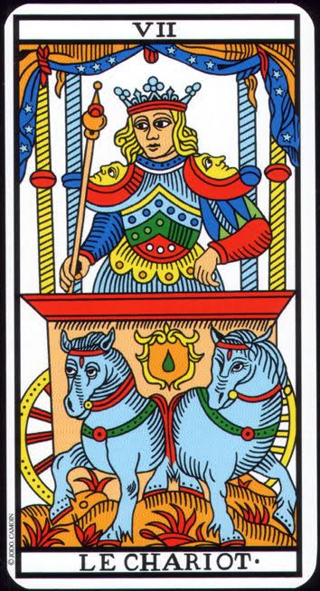
7

(27 + 32 + 11 = 70 = 7)

The Chariot

------------------------------------------------------------------------------------------------------------------------------------------------------------------------------------------------------------------------------------------------------------------------------------------------------------------------------

-----------------------------------------------------------------------------------------------------------------------------------------------------------------------------------------------------------------------------------------------------------------------------------------------------------------------------

NUMEROLOGICAL SIGNIFICANCE

23 (2 + 3 = 5) ~ 15 (1 + 5 = 6) ~ 23 + 15 = 38
------------------------------------------------------------------------------
1 + 5 = 6

FREQUENTIAL RESONANCE
XXIII Juno ~ XV The Devil ~ 38 Opposition/The Fighter


I Ching hexagram: 38 ~ Opposition
Human Design: gate 38 ~ the Fighter
Gene Key: 38 ~ Shadow ~ Struggle
Gift ~ Perseverance, Siddhi ~ Honour

15

(1 + 5 = 6)

The Devil
The Lover

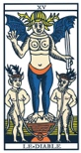
-----------------------------------------------------------------------------------------------------------------------------------------------------------------------------------------------------------------------------------------------------------------------------------------------------------------------------

-----------------------------------------------------------------------------------------------------------------------------------------------------------------------------------------------------------------------------------------------------------------------------------------------------------------------------

The Sun with the Moon on the margin

NUMEROLOGICAL SIGNIFICANCE

19 + 18 = 37 ~ 11 + 3 + 7 + 9 + 19 = 49
--------------------------------------------------------------------

19 + 18 = 37

FREQUENTIAL RESONANCE
XIX The Sun ~ XVIII The Moon’s external influence ~ 37 The Family & Friendship


I Ching hexagram: 37 ~ The Family
Human Design: gate 37 ~ Friendship
Gene Key: 37 ~ Shadow ~ Weakness
Gift ~ Equality, Siddhi ~ Tenderness

19

(1 + 9 = 10 = 1)

The Sun Wheel of Fortune Magician

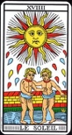
-----------------------------------------------------------------------------------------------------------------------------------------------------------------------------------------------------------------------------------------------------------------------------------------------------------------------------

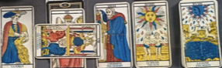
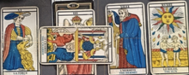

-----------------------------------------------------------------------------------------------------------------------------------------------------------------------------------------------------------------------------------------------------------------------------------------------------------------------------

-----------------------------------------------------------------------------------------------------------------------------------------------------------------------------------------------------------------------------------------------------------------------------------------------------------------------------
30 + 19 = 49 ~ 4 + 9 = 13

FREQUENTIAL RESONANCE
XIX The Sun ~ XIII Death ~ 49 Revolution/Rejection


I Ching hexagram: 49 ~ Revolution
Human Design: gate 49 ~ Rejection
Gene Key: 49 ~ Shadow ~ Rejection
Gift ~ Revolution, Siddhi ~ Rebirth

13

(1 + 3 = 4)

XIII Death to Empire
IV The Emperor

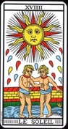

-----------------------------------------------------------------------------------------------------------------------------------------------------------------------------------------------------------------------------------------------------------------------------------------------------------------------------

-----------------------------------------------------------------------------------------------------------------------------------------------------------------------------------------------------------------------------------------------------------------------------------------------------------------------------
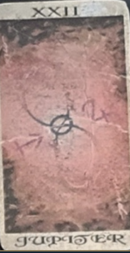

XXII Jupiter in alignment with Juno’s innate Wisdom holds the 3rd position in the lineup towards the potential outcome
Jupiter in the place of collective hopes, dreams, and fears

NUMEROLOGICAL SIGNIFICANCE
- + 22 = 28
-------------------------------------------------
6 + 22 = 28
NUMEROLOGICAL SIGNIFICANCE
VI The Lover ~ XXII Jupiter ~ The Game Player


I Ching hexagram: 28 ~ Preponderance of the Great
Human Design: gate 28 ~ the Game Player
Gene Key: 28~ Shadow ~ Purposelessness
Gift ~ Totality, Siddhi ~ Immortality

28
(2 + 8 = 10 = 1

X Wheel of Fortune
I The Magician
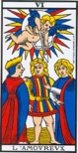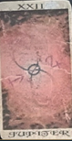
VI The Lover XXII Jupiter
-----------------------------------------------------------------------------------------------------------------------------------------------------------------------------------------------------------------------------------------------------------------------------------------------------------------------------

-----------------------------------------------------------------------------------------------------------------------------------------------------------------------------------------------------------------------------------------------------------------------------------------------------------------------------
Numerological wrap up of spread 1

15 + 19 = 34 ~ 22 + 12 = 34 ~ (3 + 4 = 7) x 2 = 14
--------------------------------------------------------------------------------------------------------------------------------------------------------------------------------
15 + 19 = 34
NUMEROLOGICAL SIGNIFICANCE
XV The Devil ~ XIX The Sun ~ 34 The Power of the Great/Might.

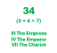

Jupiter the Hanged Man

The Hanged Man’s upside-down world

NUMEROLOGICAL SIGNIFICANCE
-------------------------------------------------
12
NUMEROLOGICAL SIGNIFICANCE
XII The Hanged Man ~ Standstill ~ Caution


I Ching hexagram: 34 ~ The Power of the Great
Human Design: gate 34 ~ Might
Gene Key: 34 ~ Shadow ~ Force
Gift ~ Strength, Siddhi ~ Majesty

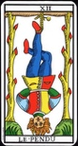
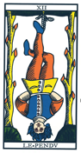


I Ching hexagram: 12 ~ Standstill
Human Design: gate 12 ~ Caution
Gene Key: 12 ~ Shadow ~ Vanity
Gift ~ Discrimination, Siddhi ~ Purity

12
(1 + 2 = 12 = 3)

I The Magician
The High Priestess
The Empress
The Hanged Man
------------------------------------------------------------------------------------------------------------------------------------------------------------------------------------------------------------------------------------------------------------------------------------------------------------------------

-----------------------------------------------------------------------------------------------------------------------------------------------------------------------------------------------------------------------------------------------------------------------------------------------------------------------------
7 + 7 = 14
NUMEROLOGICAL SIGNIFICANCE
XV The Devil ~ XIX The Sun ~ 34 The Power of the Great/Might
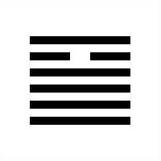

I Ching hexagram: 14 ~ Possession in Great Measure
Human Design: gate 14 ~ Power Skills
Gene Key: 14 ~ Shadow ~ Compromise
Gift ~ Competence, Siddhi ~ Bounteousness

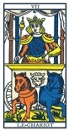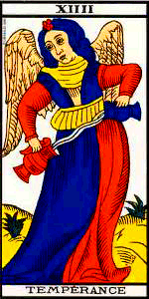
14
(1 + 4 = 5)

XIV Temperance
IV The Emperor
V The Hierophant
The Chariot Temperance

----------------------------------------------------------------------------------------------------------------------------------------------------------------------------------------------------------------------------------------------------------------------------------------------------------------------------
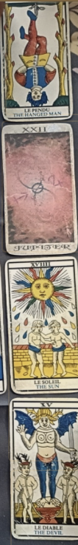

Pushing up the
vertical lineup

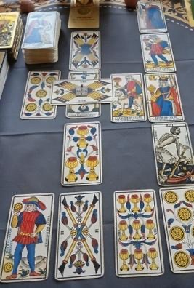

2nd spread
major & minor arcana
for November

